**PARADE USER GUIDE**

**WITSML**



**Version 1.30 Sep 2020**

**Version History**

|  |  |  |  |
| --- | --- | --- | --- |
| **Version** | **Date** | **Author** | **Comments** |
| 1.29 | Sep 2020 | K.Wilson | Original Version |
| 1.30 | Sep 2020 | K.Wilson | Added export |

Contents

Introduction 1

WITSML data files 1

Exporting data 6

WITSML export formats 8

# Introduction

**WITSML**™ is an industry initiative to provide open, non-proprietary, standard interfaces for systems transmitting, exchanging or receiving data. These standards make the seamless integration of drilling technologies possible, enabling near-real-time drilling optimization and moving closer to realizing the benefits of the digital oilfield.

It replaces the older WITS standard and is based on the XML format used in computer systems.

There are a number of different layouts of WITSML files depending on the data it contains

# WITSML data files

This option allows WITSML files to be imported into temporary tables where they can be displayed.

They can be sorted, empty columns hidden and then selected columns exported to a text file, where the data may be imported into one of the standard Parade tables, eg path or measured data.

Click on the WITSML option in the main menu to display the screen.

Initially, the 3 tables are blank.

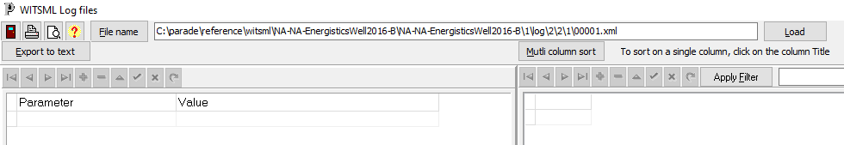

Before any data is displayed a file must be selected using a file open dialog or by typing it directly. The [File name] button will display this dialog.

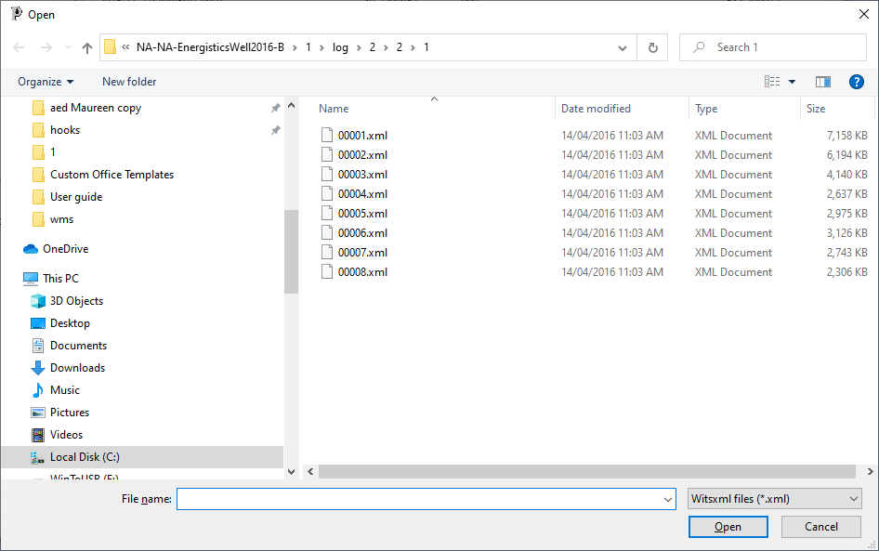

Then the [Load] button is clicked and the file read in and split into 3 tables. 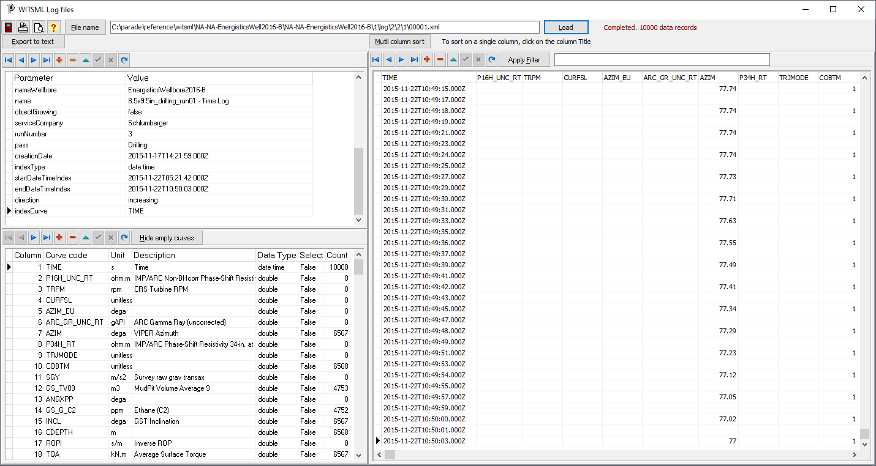

The top left table displays the header information, such as the well identifiers, times etc.

The bottom left table lists the fields in the file. This includes the WITSML code, units, a description, data time and how many values are in the table.

The right-hand table shows the actual data in the table with the curve codes as headers.

Many of the fields are empty and these can be hidden in the right hand table by clicking on the [Hide empty columns] button.

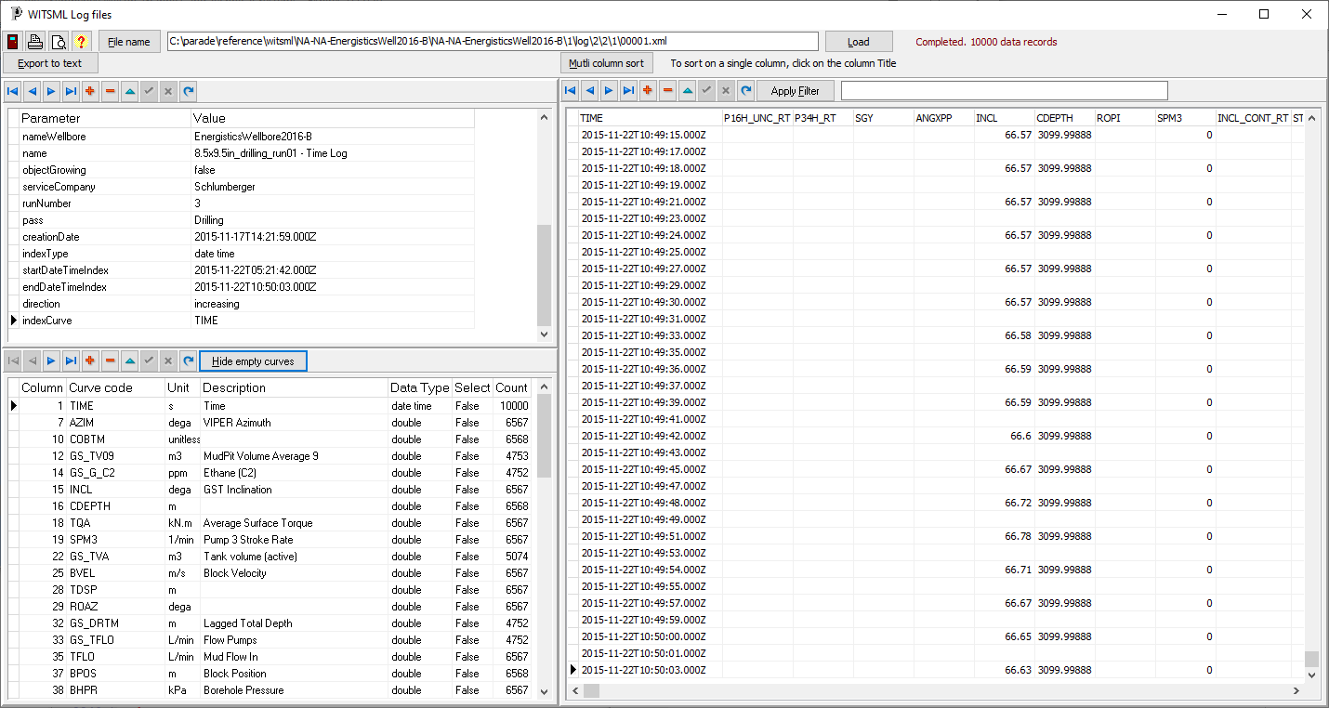

The data in the right-hand table can be sorted on a single value by clicking on the column header., eg on CDEPTH.

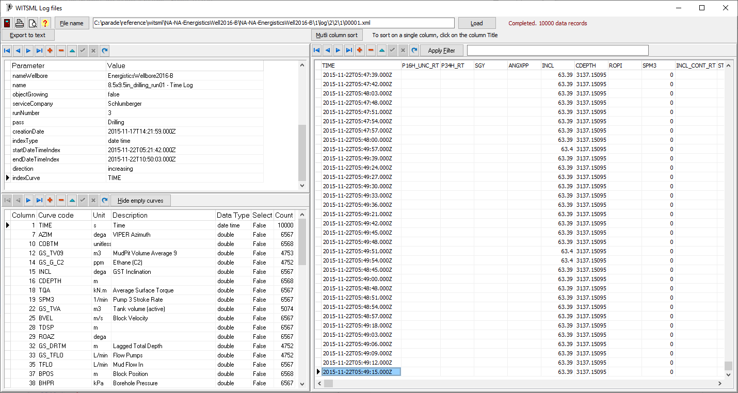

If the data is to be sorted on more than one column click on [Multi column sort] and select the columns, in order, for the sort.

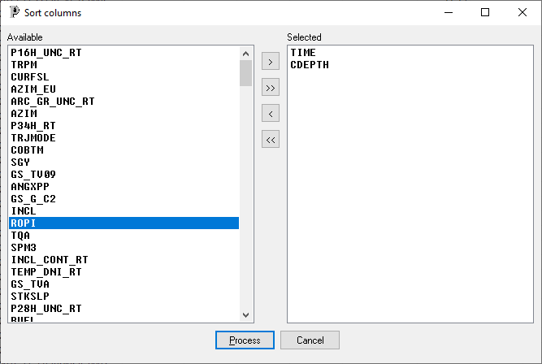

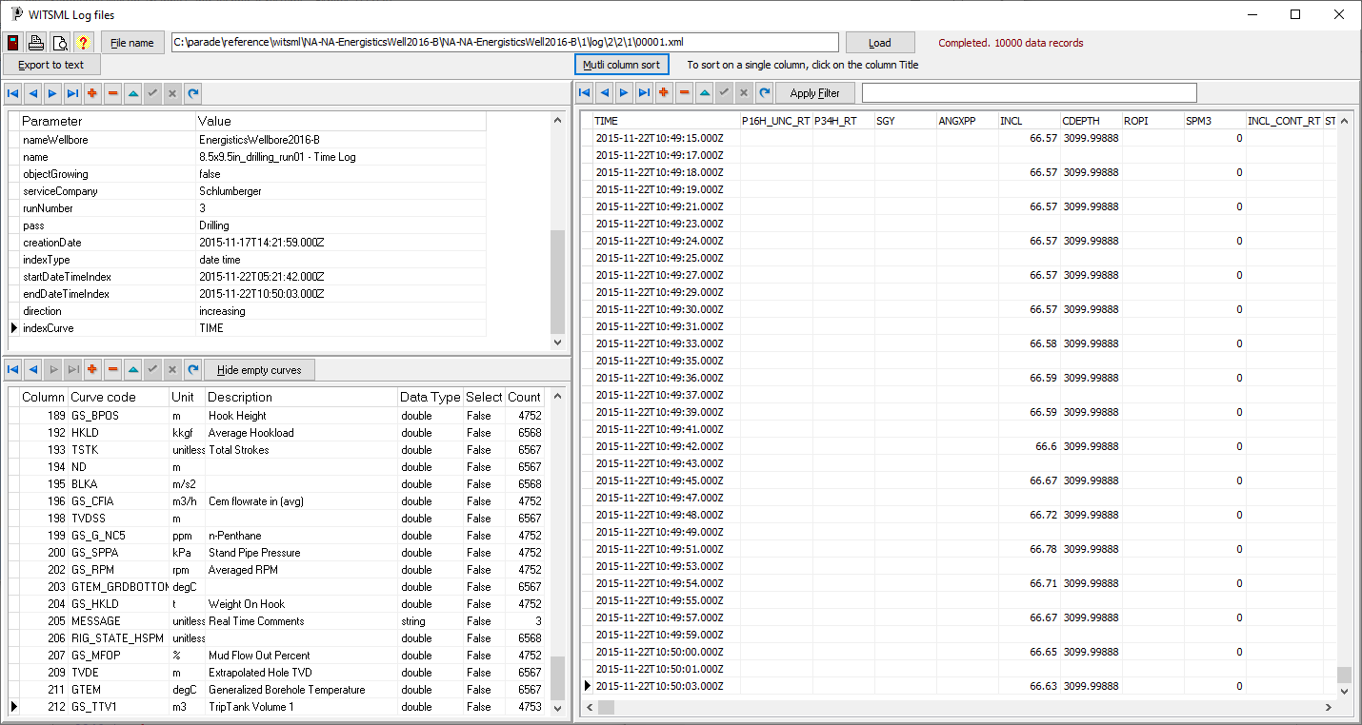

It is further possible to edit the columns displayed by applying a filter.

Eg “Incl>0” or “cdepth>3100”

Conditions can be combined using logical operations “and”, “or” and “not”. Each condition should be in brackets.

Eg “(Incl>0) or (azim>0)”

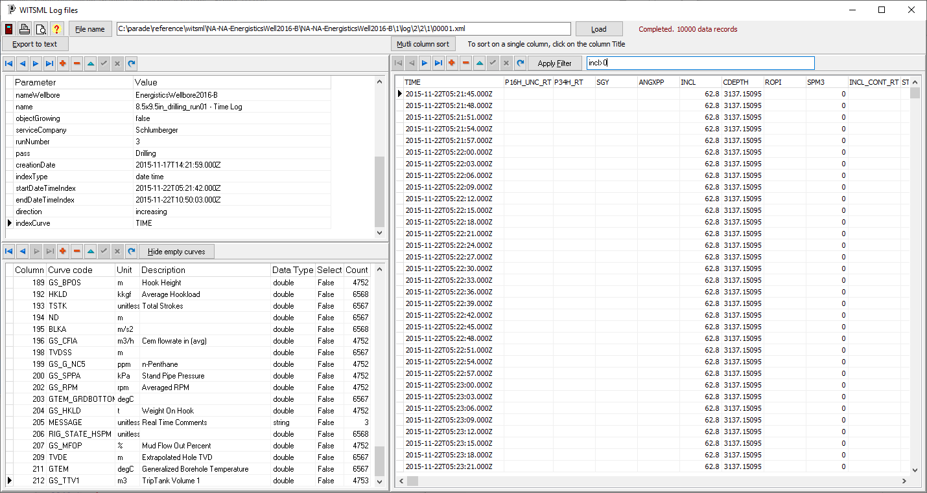

# Exporting data

Several of the Parade tables have an option to import data from a text file. Since WITSML files may contain the data for these tables, this option allows text file to be created with selected data from the WITSML file so that it can be imported.

Be aware that WITSML data is very dense, with a data point being created every few seconds. For example, a 10,000 record file may only cover data from a period of about 6 hours.

Data can be export to a tabbed delimited text file where it can be imported into parade, or viewed in Excel.

The first step is to select the columns to export. If empty columns are hidden, they will not appear in this list.

Select the columns in the order they are to appear in the text file.

Initially, no export format will be selected, however a previously saved list of fields can be used, by selecting the saved format from a drop down list.

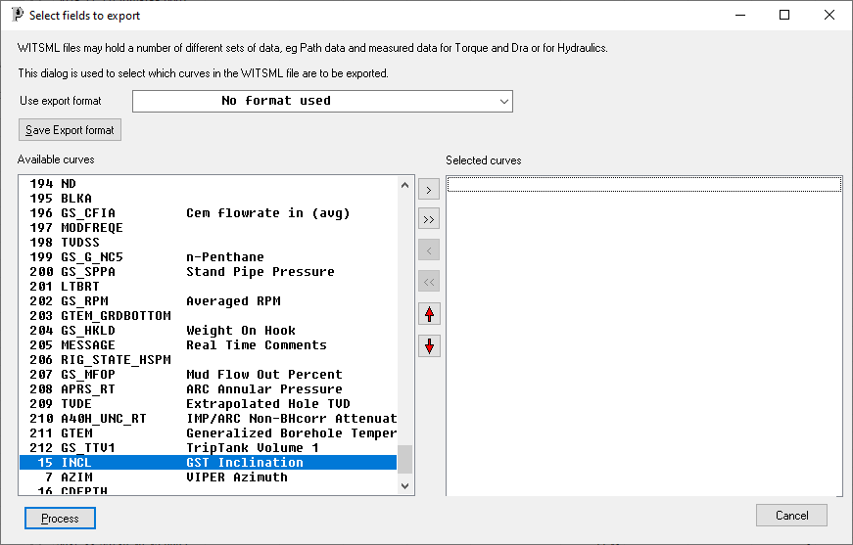 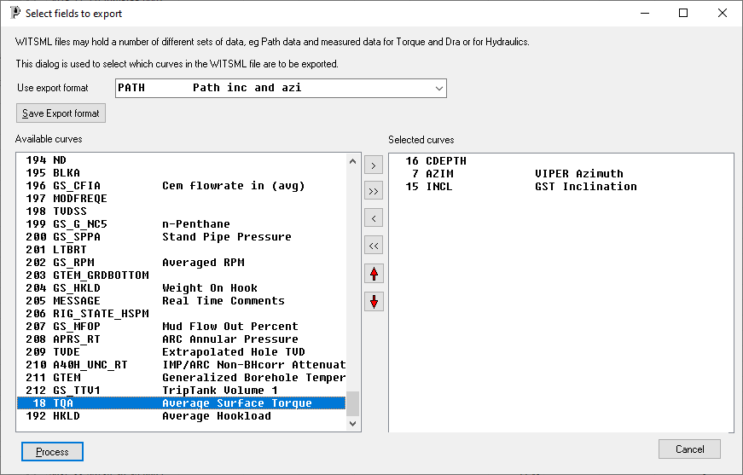

If you do not have a saved format, select the fields from the left side using the [>] button or by double clicking. The red arrow buttons move the select fields in the right list up or down.

If you have created a new list of fields manually, or modified a saved list, then this list can be saved as a WITSML export format for future use. Click on the [Save Export format] button. And enter the code and description

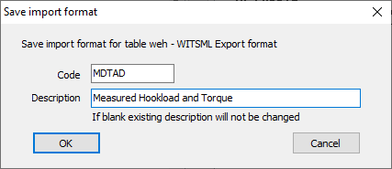

Click [Process] and a “save file dialog” will appear. The default directory is the scenario directory and the filename will be the format name, if defined, then a dash (-), followed by the source WITSML name and extension TXT. These can both be changed if needed.

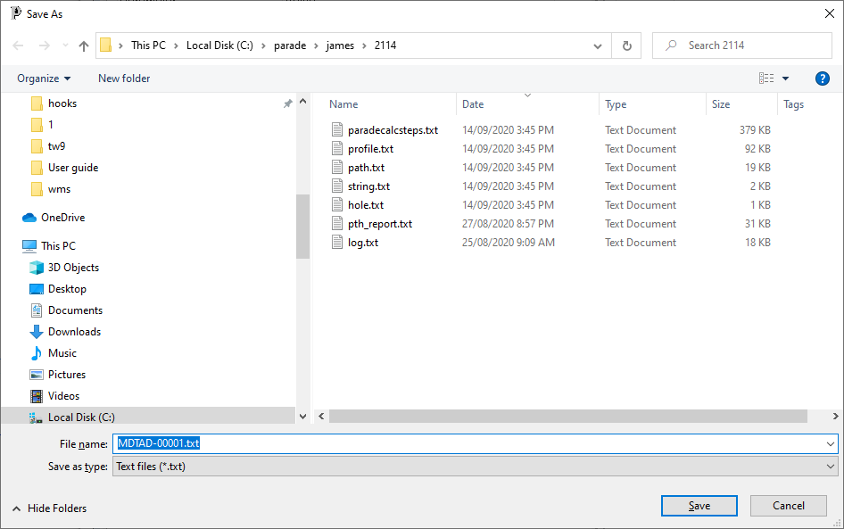

The export routine will only export visible rows in the grid and will also ignore any empty lines, so if none of the selected columns have a value for the particular row, it will be ignored.

The text file will have 2 header lines. The first line will show the field names for each curve and the second line will show the units for the curves.

It is possible to extract more than 1 set of data from a single WITSML file. For example a MWD file may have Path data, Measured T&D data and Measured Hydraulics data.

# WITSML export formats

The saved export formats can be viewed on the Library menu.

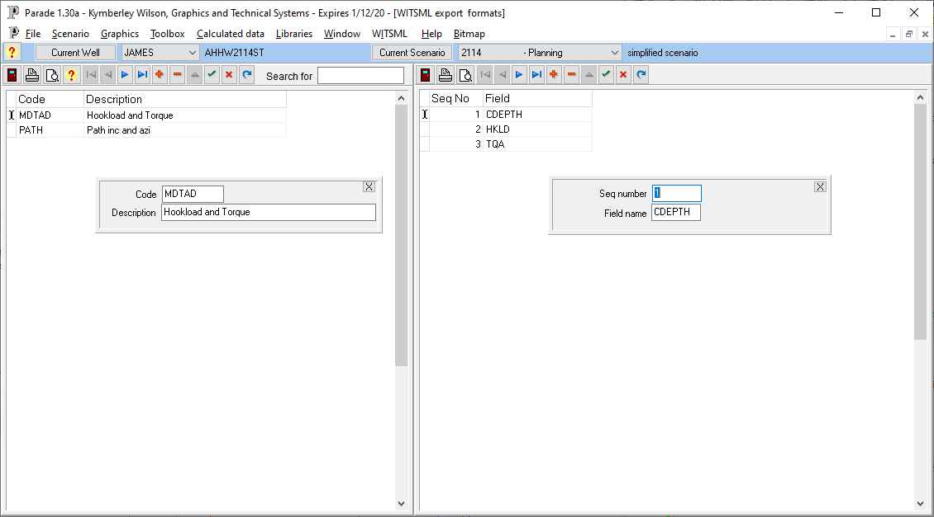

The left grid lists the saved formats.

The right grid lists the field names, in sequence for the selected format.